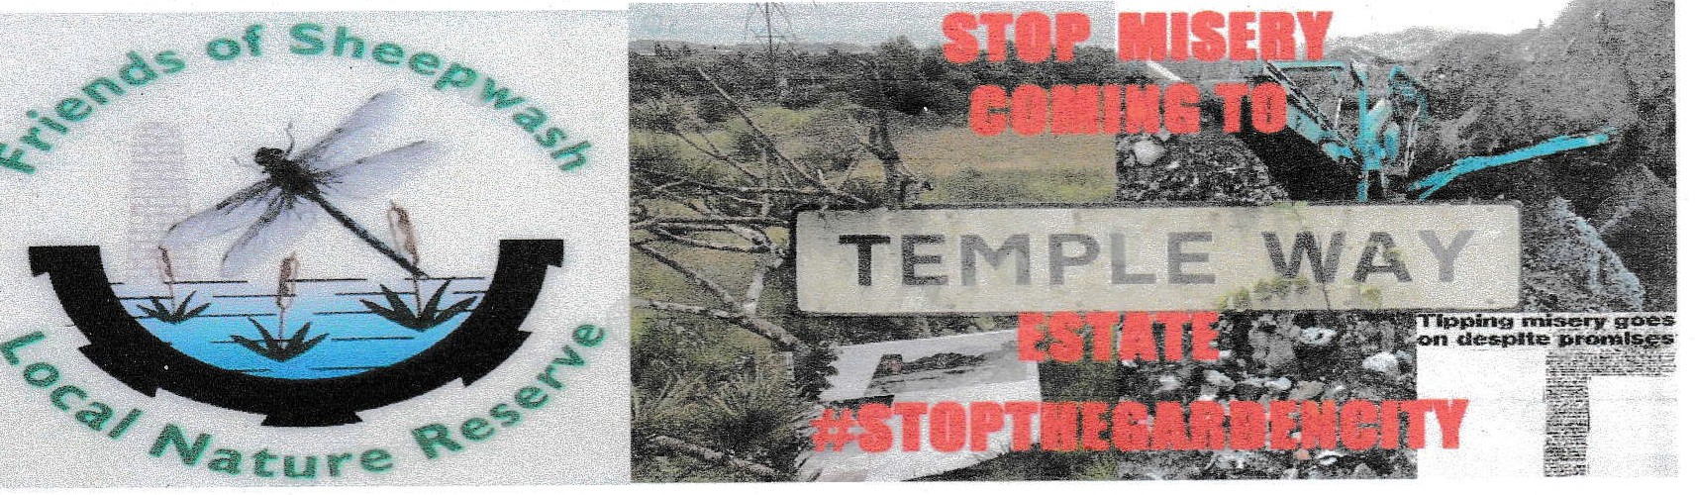
We the undersigned object to the Sandwell local Plan housing site allocations at land off and including Rattlechain lagoon (SH35 AND SHl6). This unsustainable plan is unsound and does not protect wildlife or people from inappropriate development on a contaminated landfill and is unlikely to b financed by priv te investm nt but by the tax p yer. We grefer to see the Temple Way Green space as a nature corridor linking to Sheepwash Local Nature Reserve, a Site of Importance for Nature Conservation and within the Sandwell Nature Recovery Network.

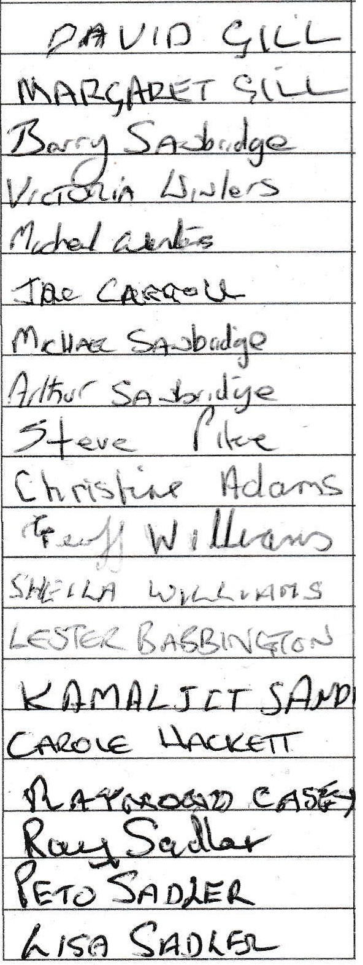
(PLEASE PRINT YOUR FULL NAME, ADDRESS AND POSTCODE)

NAME | ADDRESS SIGNATURE
'J'AN CA<\<lol-l

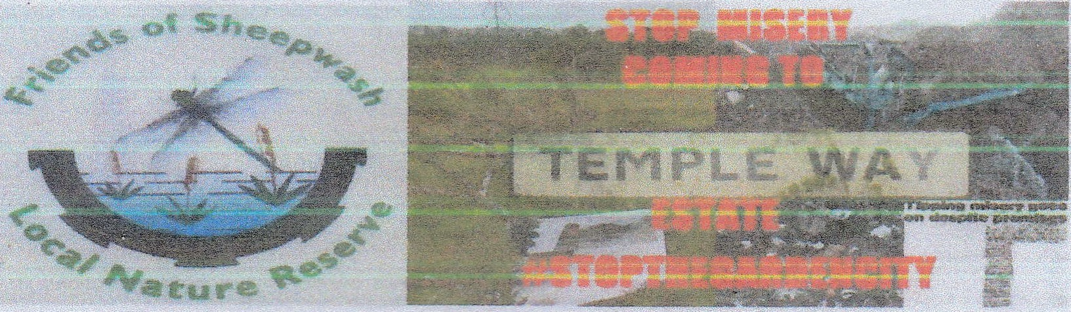
We the undersigned object to the Sandwell Local Plan hOusing site allocat1ons at land off and including Rattlechain lagoon (SH35 ANDS ). This unsustainable plan is unsound and does not protect wildlife or people from inappropriate development on a contaminated landfill and is unlikely to be financed by private investment but by the tax payer. We prefer to see the Temple Way Green space as a nature corridor linking to Sheepwash Local Nature Reserve, a Site of Importance for Nature Conservation and within the Sandwelt Nature Recovery Network.
(PLEASE PRINT YOUR FULL NAME, ADDRESS ANO POSTCODE)

NAME ADDRESS SIGNATURE
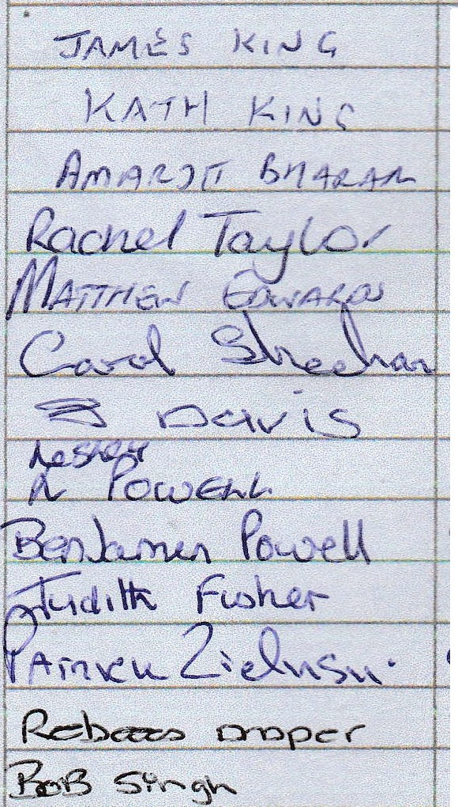
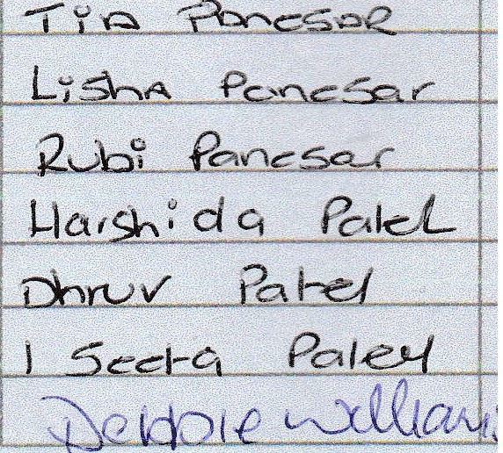

--·------



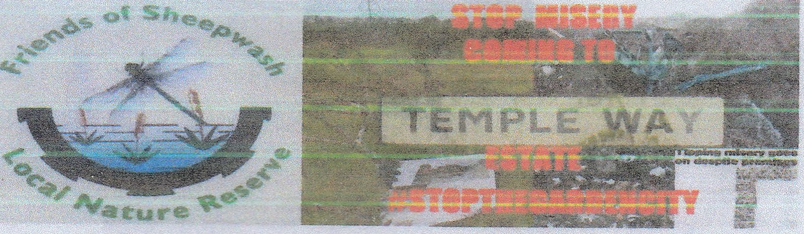
We the undersigned ob <!ct to the !>andwetl Local Plan housmg site allocat,ons at land off and including Rattlechain lagoon (SH35 AND S ). This unsustainable plan is unsound and does not protect wildlife or people from inappropriate development on a contaminated landfill and is unlikely to be financed by private investment but by the tax payer. We prefer to see the Temple Way Green space as a nature corridor linking to Sheepwash Local Nature Reserve, a Site of Importance for Nature Conservation and within the Sandwell Nature Recovery Network.

{PLEASE PRINT YOUR FUU. NAME, ADDRESS ANO POSTCODE)
NAME ADDRESS SIGNATURE
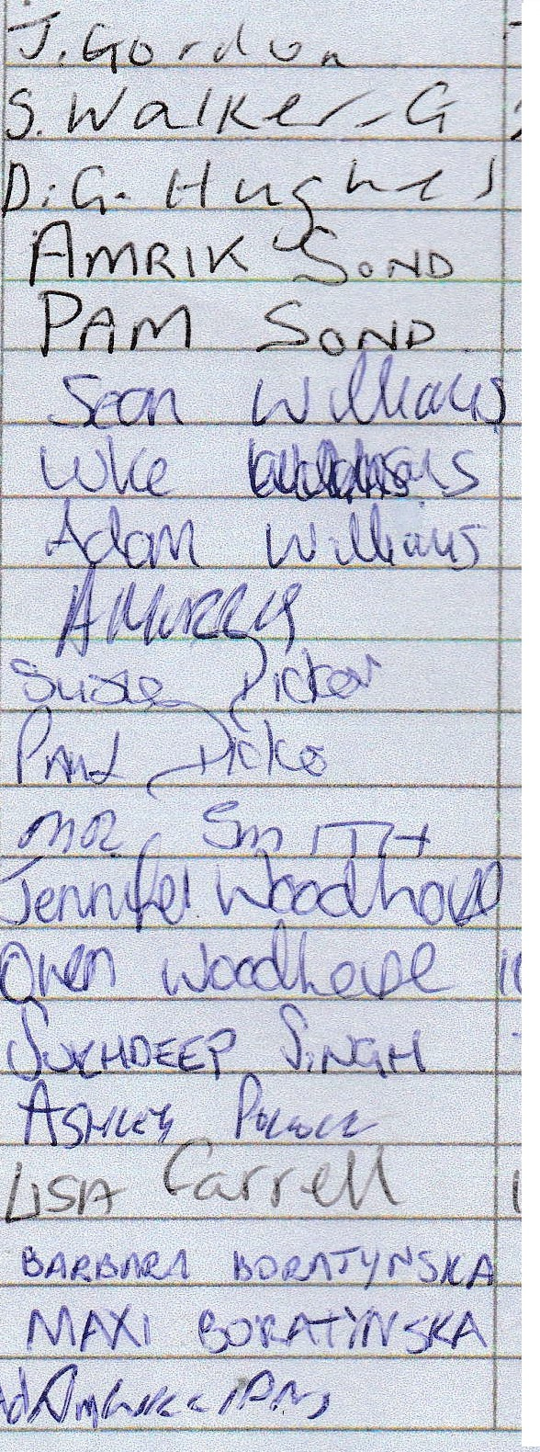

ADDRESS
SIGNATURE
---
'

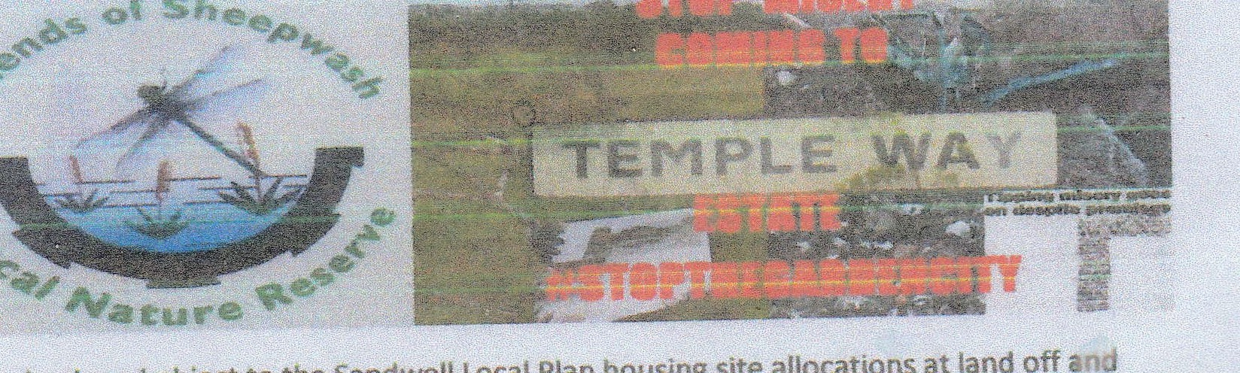
We the undersigned object t-0 the Sandwell Local Plan hOusing site allocations at land off including Rattlechain Lagoon (SH35 AND SH 6). This unsustainable plan is unsound and does not
protect wildlife or people from inappropriate development on a contaminated landfill and is unlikely to be financed by private investment but by the tax payer. We prefer to see the Temple Way Green space asa nature corridor linking to Sheepwash Local Nature Reserve, a Site of Importance for Nature Conservation and within the Sandwell Nature Recovery Network.

(PLEASE PRINT YOUR FULL NAME, ADDRESS ANO POSTCODE}
NAME

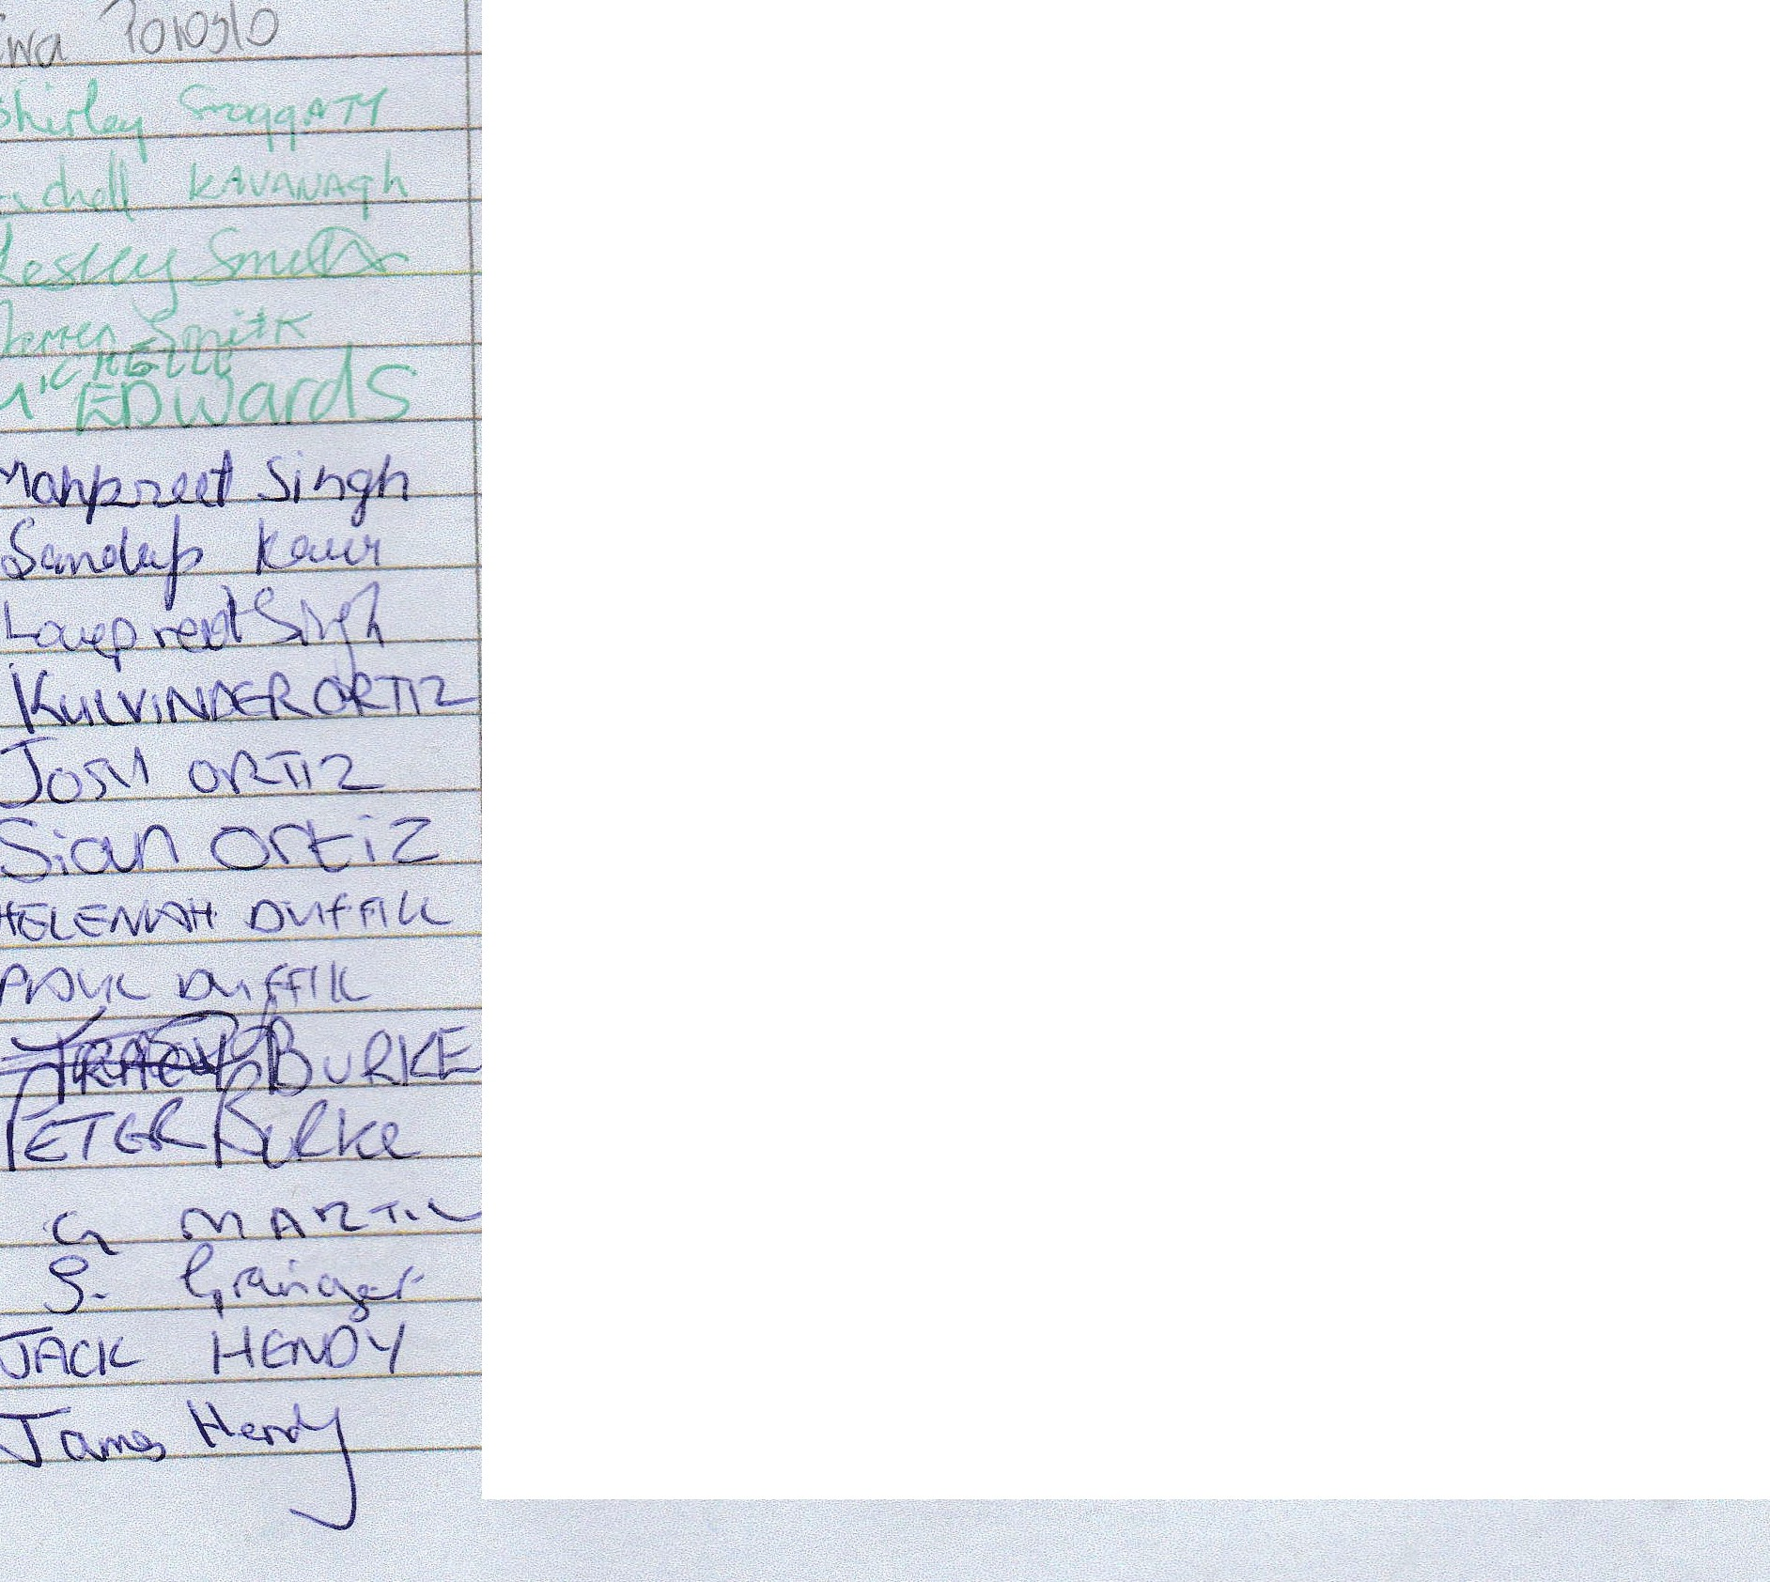


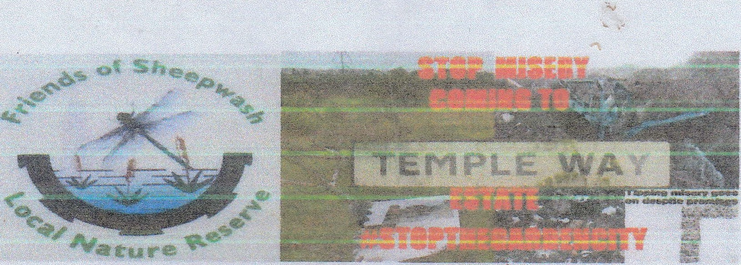
We the undersigned object to the Sandwell Local Plan hOusing site allocat,ons at land off and including Rattlechain Lagoon (SH35 ANDS ). This unsustainable ptan is unsound and does not protect wildlife or people from inappropriate development on a contaminated landfill and is unlikely to be financed by private investment but by the tax payer. We prefer to see the Temple Way Green space as a nature corridor linking to Sheepwash Local Nature Reserve, a Site of Importance for Nature Conservation and within the Sandwell Nature Recovery Network.
(PLEASE PRINT YOUR FULL NAME, A0PRESS AND POSTCOPE}
NAME ADDRESS SIGNATURE
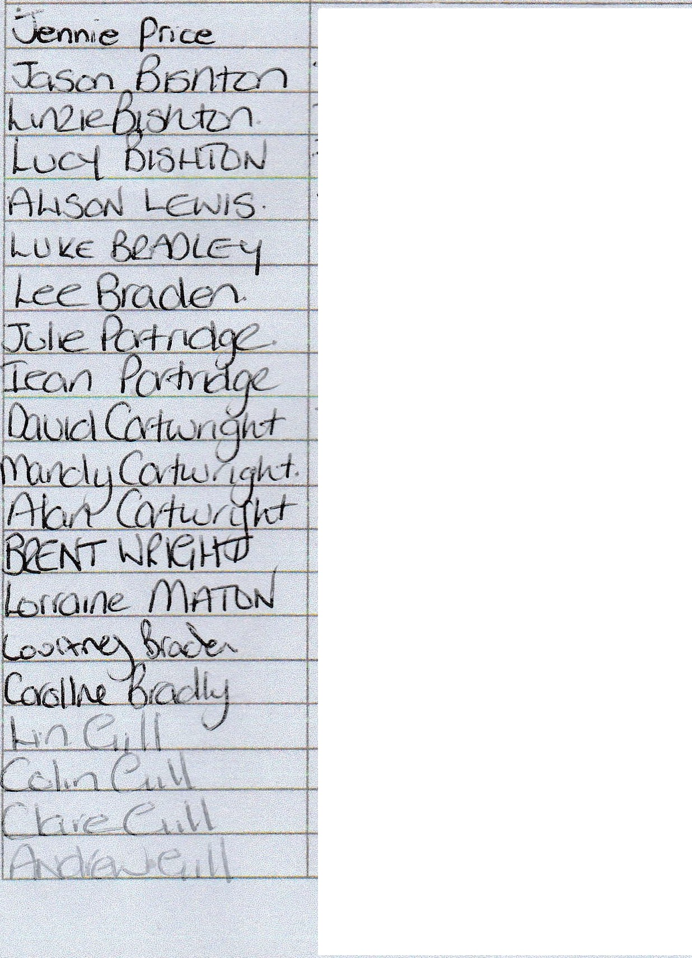

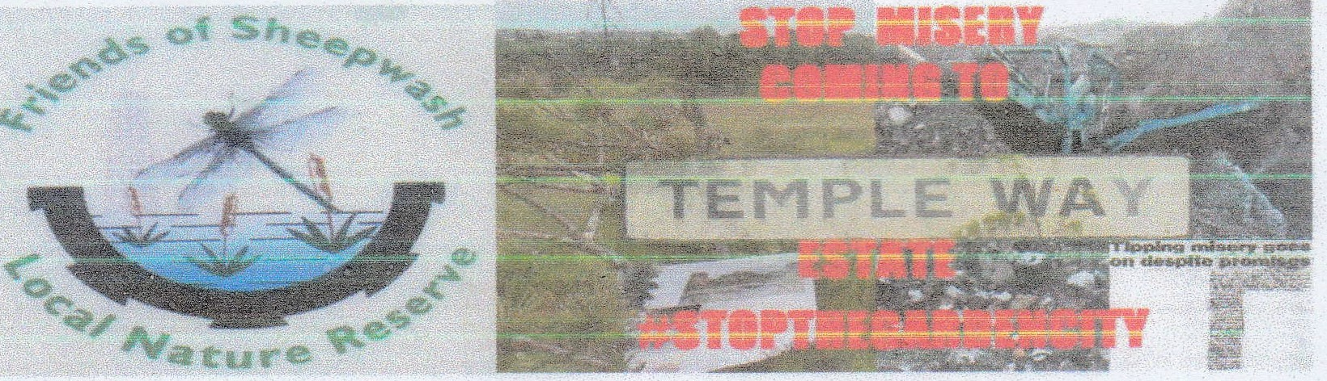
We the undersigned object to the Sandwell Local Plan housing site atlocations at land off and including Rattlechain Lagoon (SH35 AND SH36). This unsustainable plan is unsound and does not protect wildlife or people from inappropri te development on a contaminated landfill and is unlikely. to be financed by private investment but by the tax payer. We prefer to see the Temple Way Green space as a nature corridor linking to Sheepwash Local Nature Reserve, a Site of Importance for Nature Conservation and within the sandwell Nature Recovery Network.

(PLEASE PRINT YOUR FULL NAME, ADDRESS AND POSTCODE)

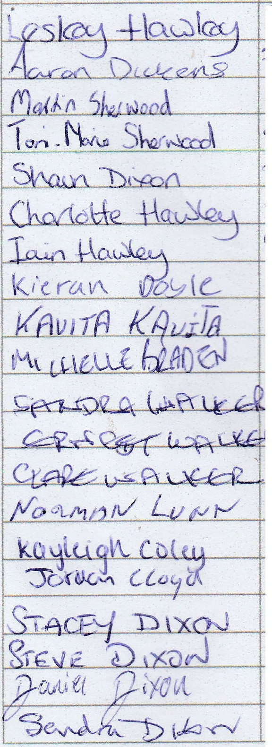
NAME
SIGNATURE

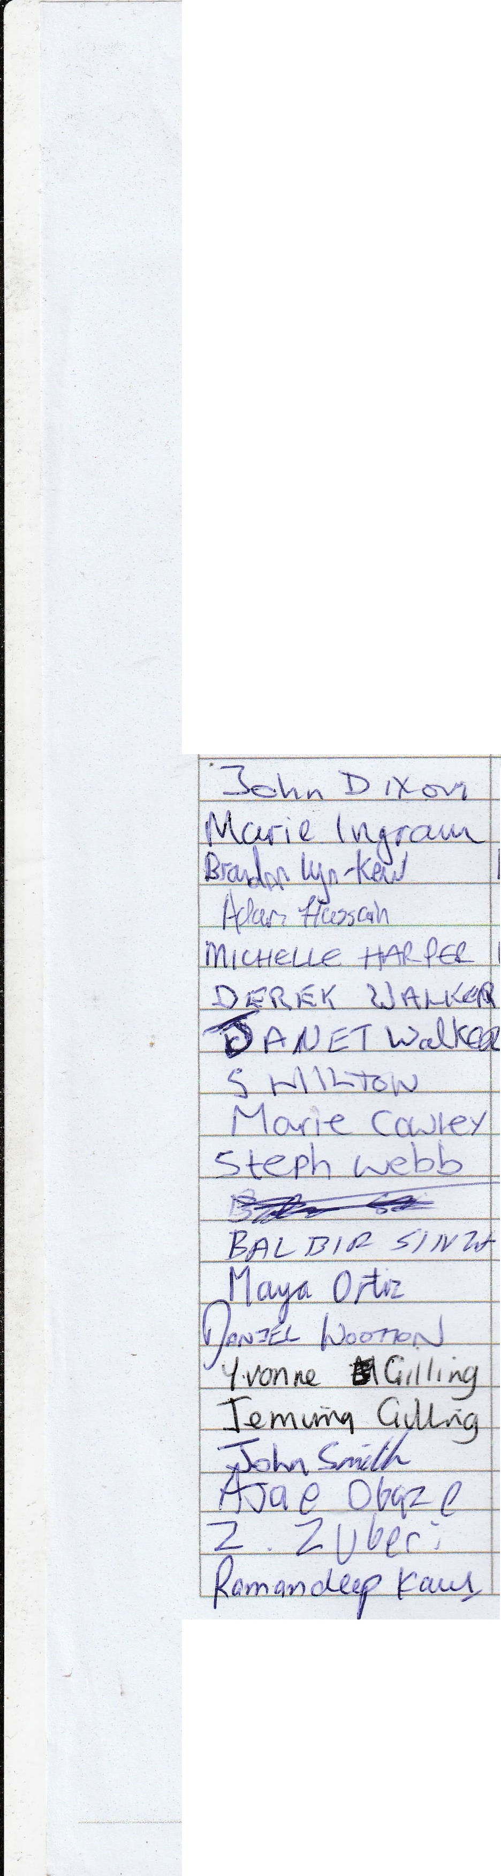
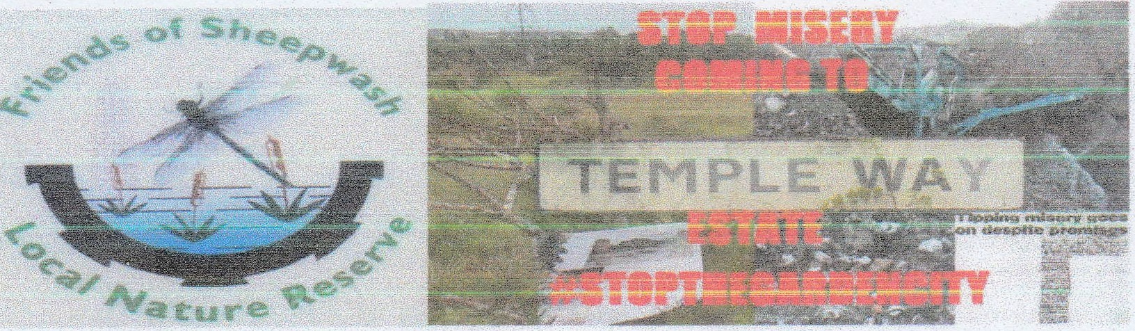
,,_ .

We the undersigned object to the Sandwell Local Plan housing site allocations at land off and including Rattlechain lagoon (SH35 AND SH36). This unsustainable plan is unsound and does not protect wildlife or people from inappropriate development on a contaminated landfill and is unlikely to be financed by private investment but by the tax payer. We prefer to see the Temple Way Green space as a nature corridor linking to Sheepwash Local Nature Reserve, a Site of Importance for Nature Conservation and within the Sandwell Nature Recovery Network.
{PLEASE PRINT YOUR FULL NAME, ADDRESS AND POSTCODE)

NAME | ADDRESS | SIGNATURE

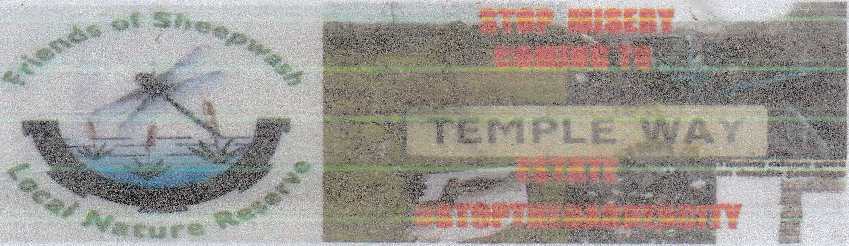
We the understgned object o the Sanowell Loca P an housing site allocanons at land off and including Rattlechain Lagoon (SH35 AND Slt.36). This unsu ainable plan is unsound and does not protect wildlife or pe p e from inappropriate development on a contaminated landfill and is unlikely
to b financed by private in ment but by t e tax payer. We prefer to see the Temp e Way Green
space as a nature corridor linking to Sheepwash Local Nature Reserve, a Site of Importance for

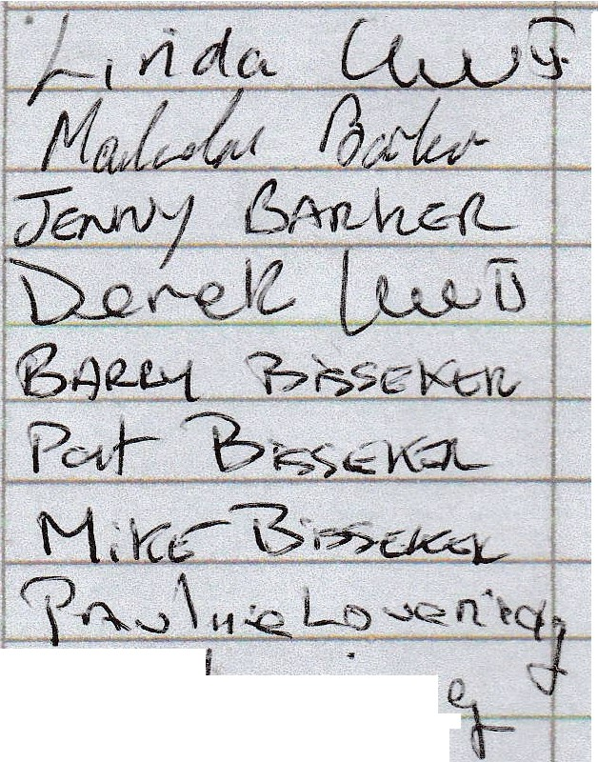
HatuNI Conservation an within the X1111reH Nature Recovery etwork.

N.P-\"'-./l f\...lcl_
L NLo r----tU, _
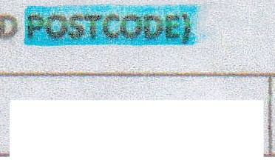

(Pt.EASE PRINT YOUR FULL N £.
NAME
ADDRESS
SIGNATURE

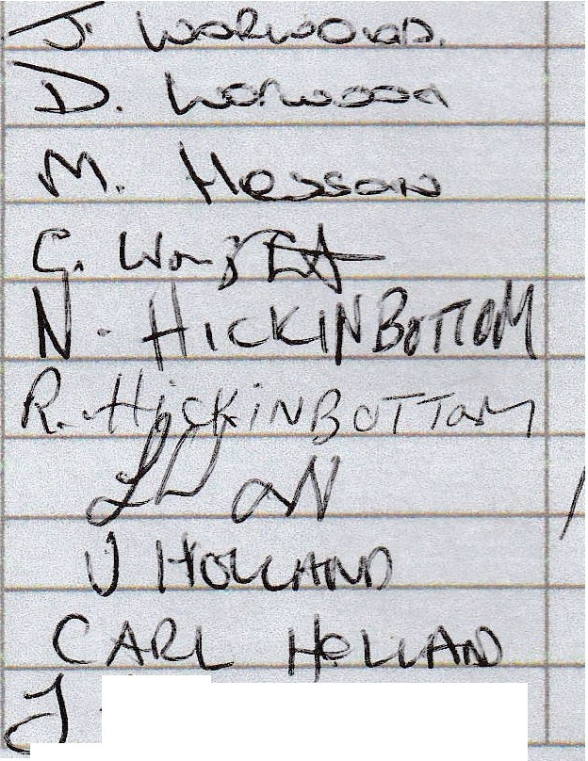

_ fuWM't:h
/'-{_ . D avv N, "½ C:

.s· lJdi.;

. .
-
-

,.'
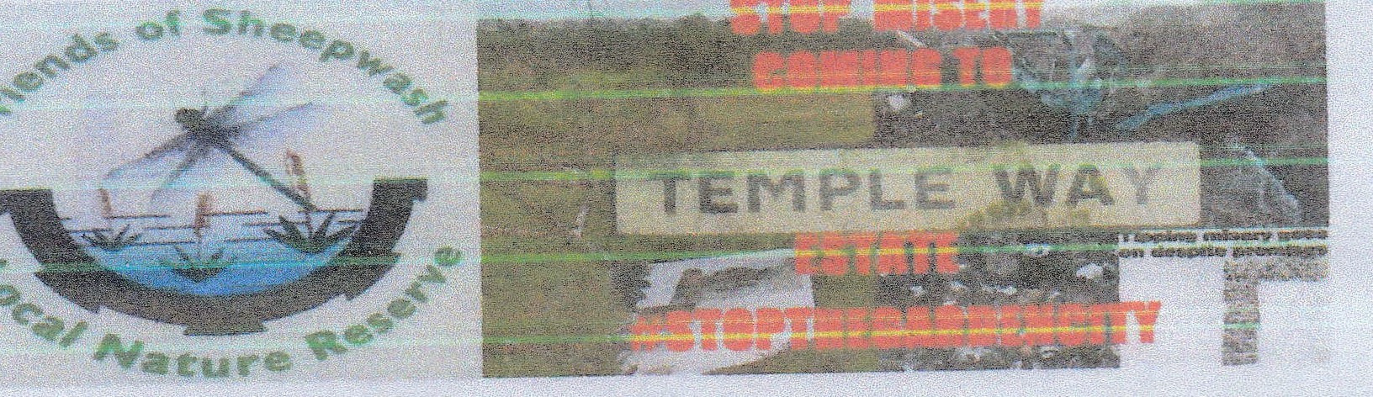
We the undersigned object to the Sandwell local Plan housmg site allocat1ons at land off and including Rattlechain lagoon (SH35 AND SH36). This unsustainable plan is unsound and does not protect wildlife or people from inappropriate development on a contaminated landfill and is unlikely to be financed by private investment but by the tax payer. We prefer to see the Temple Way Green space as a nature corridor linking to Sheepwash Local Nature Reserve, a Site of Importance for Nature Conservation and within the Sandwell Nature Recovery Network.

(PLEASE PRINT YOUR FULL NAME, ADDRESS AND POSTCOPI:}
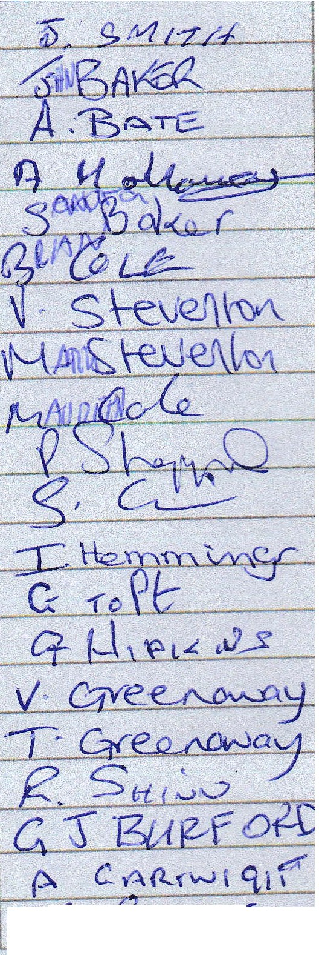
NAME
ADDRESS
SIGNATURE
f-/. oooc
G-
-u
-=s\C'l¼

c{2:JI,::
J:: flti, Ii-1l &:>
..4 m 1A,zl)S

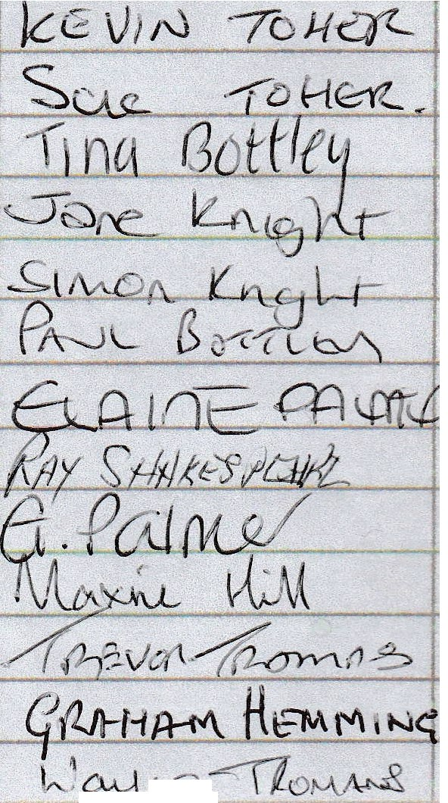
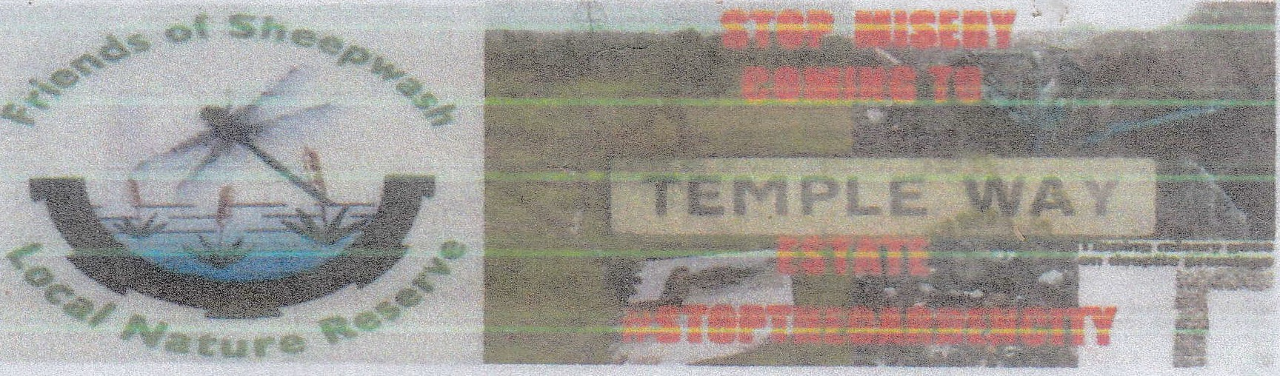
We the undersigned object to the Sand ti Local Plan housmg site atlocations at land off and including Rattlechain Lagoon (SH35 AND This unsustainable plan is unsound and does not protect wildlife-or people from inapprop t development on a contaminated landfill and is unlikely to be financed by private Inv stm n but by t e tax payer. We prefer to see the Tempe Vay Green space asa nature corridor linking to heepwash Local Nature Reserve, a Site of Importance for Nature Cons rvation and within Sandwell Nature ec-overy Networtc.

(PLEASE PRINT YOUR FULL N ADDRESS D POSTCODE)
NAME ADDRESS SIGNATURE

, jlQ
A J
?RiuC.. :5'
iZ w 1,10 /2..( e?cf-,,J
fl /( Coo PuJ\.
r11t11tT Irv ,r ,;
-_ \\f\.C /J . <t

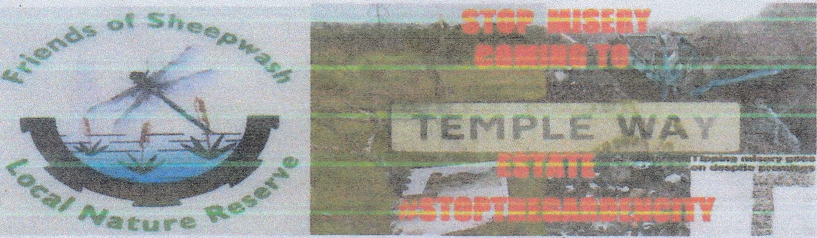
We the undersigned object to the Sandwell Local Plan housing site allocations at land off and including Rattlechain lagoon (SH35 AND s ). This unsustainable ptan is unsound and does not protect wildlife or people from inappropriate development on a contaminated landfill and isunlikely
to be financed by private investment but by the tax payer. We prefer to see the Temple Way Green space as a nature corridor linking to Sheepwash Local Nature Reserve, a Site of Importance for Nature Conservation and within the SandweU Nature Recovery Network.
(PLEASE PRINT YOUR FUU. NAME, ADDRESS ANO PO$TCOOE)
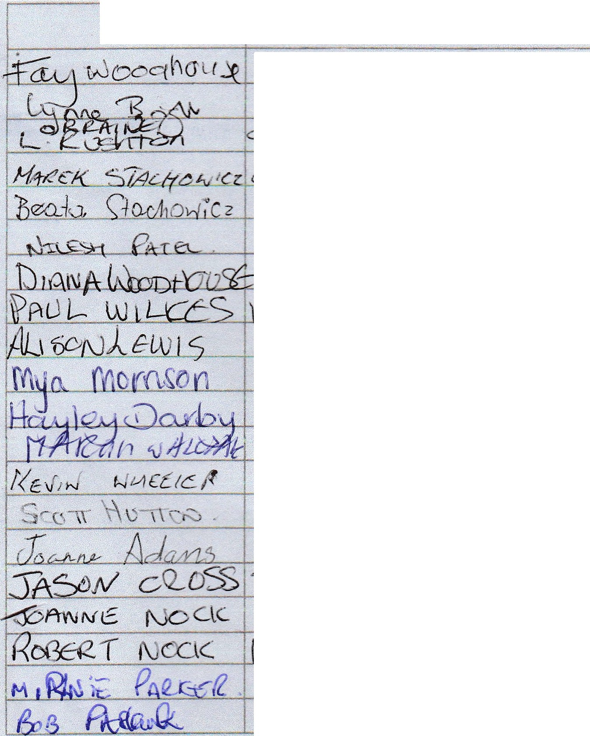
NAME
ADDRESS
, - !• /)GNATURE

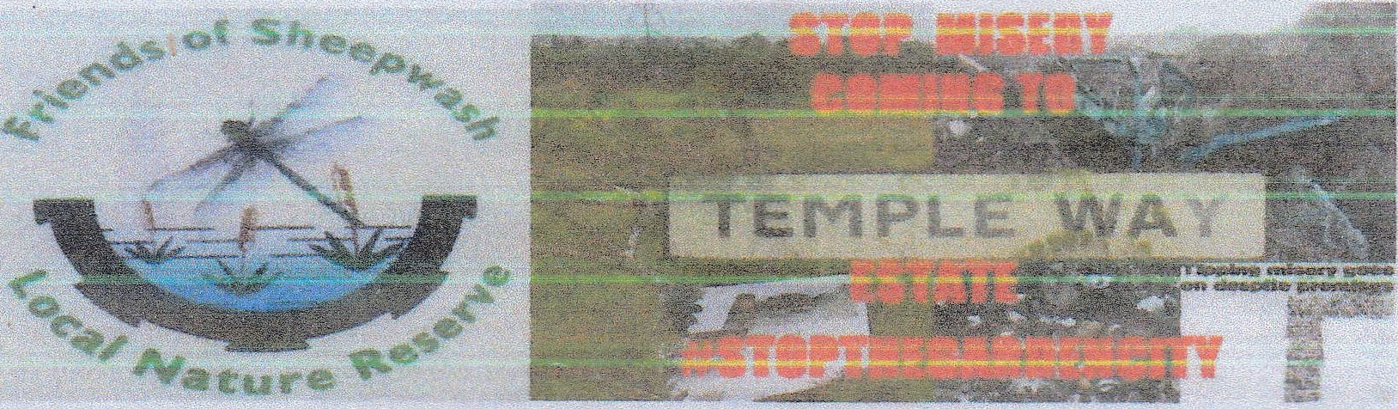
We the undersigned object to the Sandwell Local Plan nousmg site allocations at land off and including Rattlechain Lagoon (SH35 AND SH)6). This unsustainable plan is unsound and does not protect wildlife or people from inappropriate development on a contaminated landfill and is unlikely to be financed by private investment but by the tax payer. We prefer to see the Temple Way Green space as a nature corridor linking to Sheepwash Local Nature Reserve, a Site of Importance for Nature Conservation and within the SandweH Nature Recovery Network.

(PLEASE PRINT YOUR FULL NAME, ADDRESS AND POSTCODE}

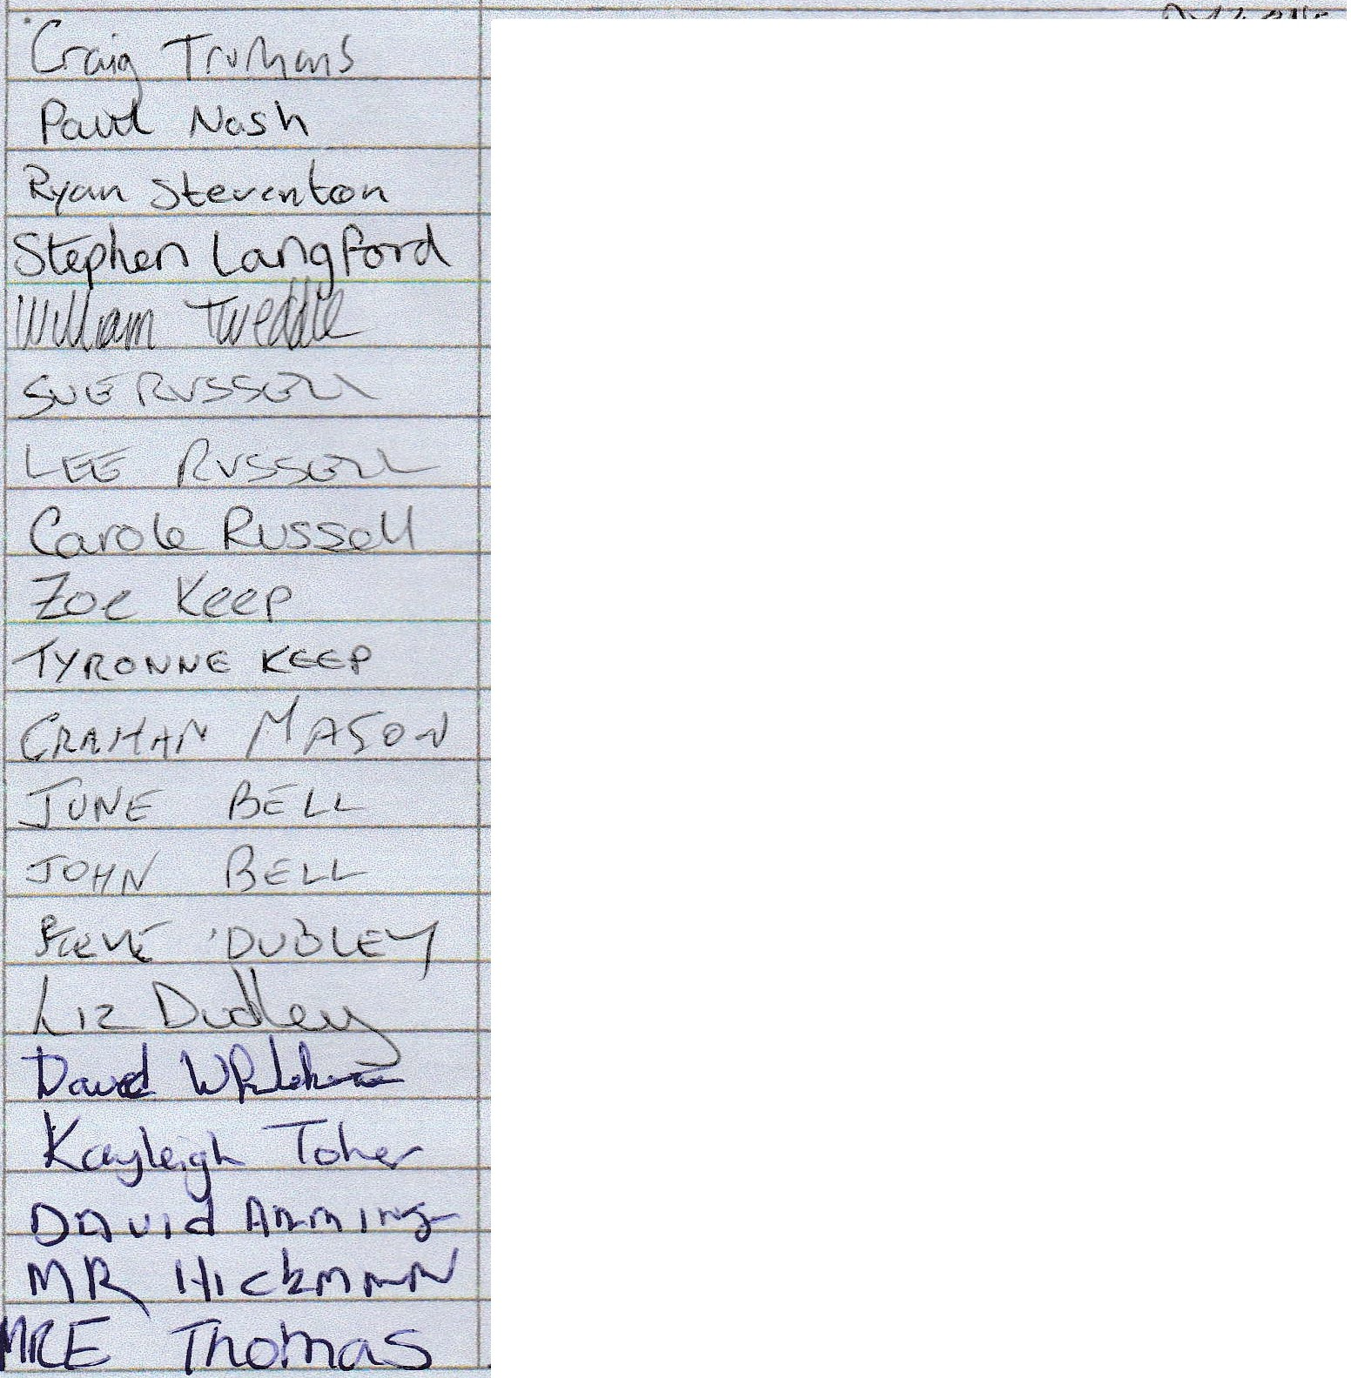
NAME
ADDRESS

